MODULE 5 ASSESSMENT

Create a Bash script 'file_analyzer.sh', to demonstrate the following concepts:
1. Recursive functions
- Write a recursive function to search for files in a directory and its subdirectories containing a specific keyword.
2. Redirection and error handling
- Log errors (e.g., invalid arguments, missing files) to 'errors.log' and display them in the terminal.
3. Here document and here string
- Use a here document to display a help menu when the '--help' option is passed.
- Search for a keyword in a specified file using a here string
4. Special parameters
- Use parameters like '$0', '$#', '$?' and '$@' to provide meaningful feedback.
5. Regular expressions
- Validate inputs with regular expressions (Check if the file exists and the keyword is not empty and valid)
6. Command-line arguments using getopts
- Use 'getopts' to handle:
'-d <directory>': Directory to search.
'-k <keyword>': Keyword to search.
'-f <file>': File to search directly.
'--help': Display the help menu.
Example usage:
# Recursively search a directory for a keyword
./file_analyzer.sh -d logs -k error
# Search for a keyword in a file
./file_analyzer.sh -f script.sh -k TODO
# Display the help menu
./file_analyzer.sh --help

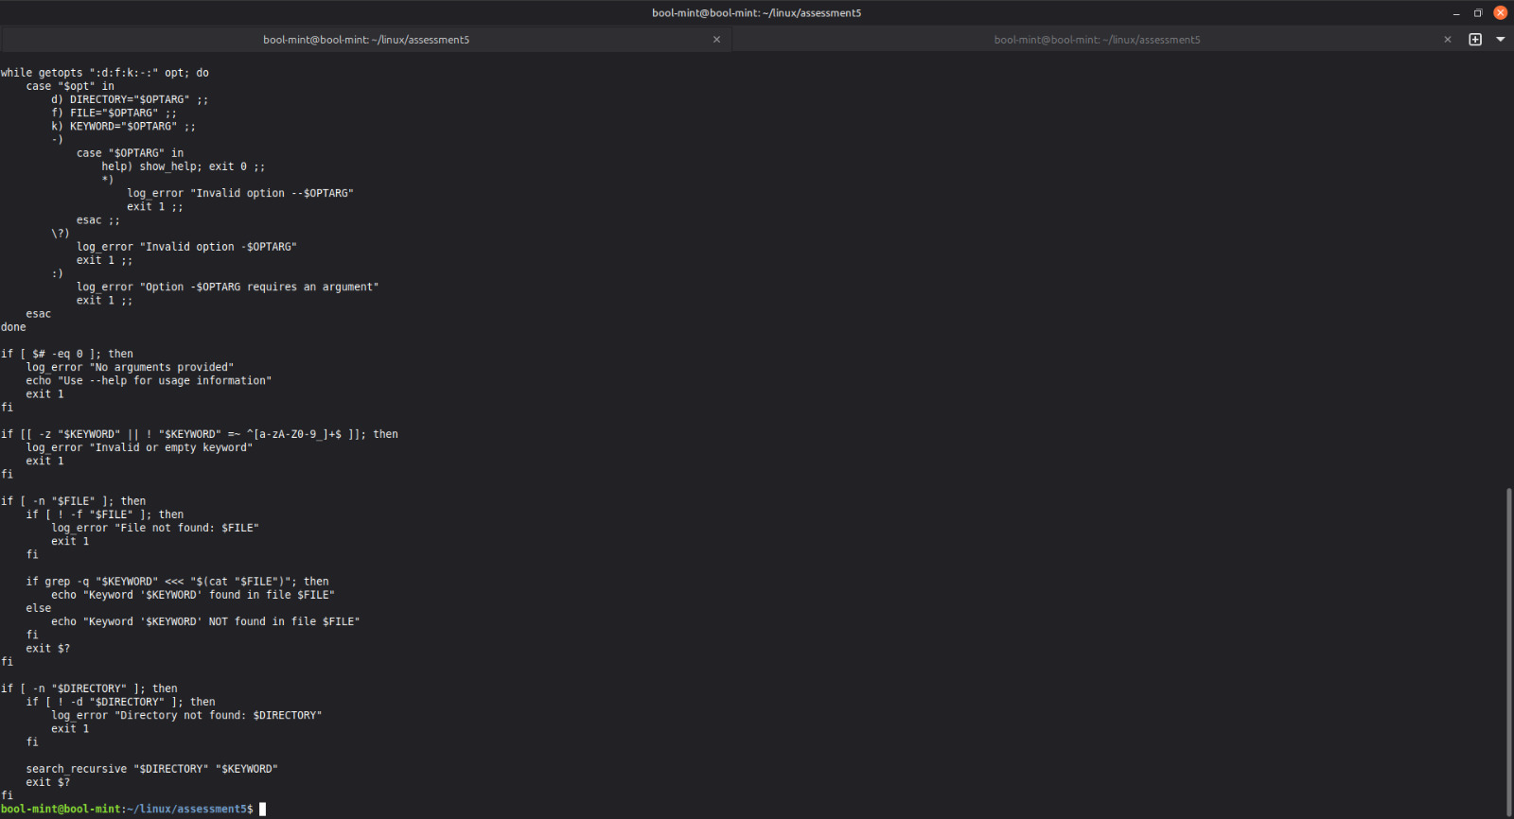
#!/bin/bash

ERROR_LOG="errors.log"

show_help() {
cat << EOF
Usage: $0 [OPTIONS]

Options:
-d <directory> Directory to search recursively
-f <file> File to search directly
-k <keyword> Keyword to search
--help Display this help menu

Examples:
$0 -d logs -k error
$0 -f script.sh -k TODO
EOF
}

log_error() {
echo "ERROR: $1" | tee -a "$ERROR_LOG"
}

search_recursive() {
local dir="$1"
local keyword="$2"

for item in "$dir"/*; do
if [ -d "$item" ]; then
search_recursive "$item" "$keyword"
elif [ -f "$item" ]; then
if grep -q "$keyword" "$item" 2>>"$ERROR_LOG"; then
echo "Match found in: $item"
fi
fi
done
}

DIRECTORY=""
FILE=""
KEYWORD=""

while getopts ":d:f:k:-:" opt; do
case "$opt" in
d) DIRECTORY="$OPTARG" ;;
f) FILE="$OPTARG" ;;
k) KEYWORD="$OPTARG" ;;
-)
case "$OPTARG" in
help) show_help; exit 0 ;;
*)
log_error "Invalid option --$OPTARG"
exit 1 ;;
esac ;;
\?)
log_error "Invalid option -$OPTARG"
exit 1 ;;
:)
log_error "Option -$OPTARG requires an argument"
exit 1 ;;
esac
done

if [ $# -eq 0 ]; then
log_error "No arguments provided"
echo "Use --help for usage information"
exit 1
fi

if [[ -z "$KEYWORD" || ! "$KEYWORD" =~ ^[a-zA-Z0-9_]+$ ]]; then
log_error "Invalid or empty keyword"
exit 1
fi

if [ -n "$FILE" ]; then
if [ ! -f "$FILE" ]; then
log_error "File not found: $FILE"
exit 1
fi

if grep -q "$KEYWORD" <<< "$(cat "$FILE")"; then
echo "Keyword '$KEYWORD' found in file $FILE"
else
echo "Keyword '$KEYWORD' NOT found in file $FILE"
fi
exit $?
fi

if [ -n "$DIRECTORY" ]; then
if [ ! -d "$DIRECTORY" ]; then
log_error "Directory not found: $DIRECTORY"
exit 1
fi

search_recursive "$DIRECTORY" "$KEYWORD"
exit $?
fi

